1. A constantly accelerating particle travels for 4 s. If it travels 240 m and reaches a velocity of 100 m/s, what was its initial velocity?

(A) 0 m/s

(B) 20 m/s

(C) 25 m/s

(D) 60 m/s

(E) 75 m/s

2. A projectile launched straight up at 10 m/s will reach a maximum height of:

(A) 5 m

(B) 10 m

(C) 25 m

(D) 50 m

(E) 75 m

3. A sensitive galvanometer has a resistance of 180 Ω and requires 2.4 µA of current to produce a full-scale deflection. The shunt resistance needed to construct an ammeter that gives full-scale deflection at a current of 1 mA is approximately

(A) 0.43 Ω

(B) 0.67 Ω

(C) 0.22 Ω

(D) 0.86 Ω

(E) 1.72 Ω

4. A 5 kg object is dropped from a plane. After a few seconds, it moves at a constant velocity. What is the force of air resistance acting on the object once it has reached a constant velocity?

(A) 0 N

(B) 25 N

(C) 50 N

(D) 100 N

(E) 150 N

5. A 220 g container is sitting on a rough horizontal surface. When a 2.71 N force is applied to the container horizontally it accelerates at 3.07 m/s2. What is the force of friction between the container and the rough surface?

(A) 0 N

(B) 0.3 N

(C) 0.5 N

(D) 1 N

(E) 2.03 N

6. A ball is rolled along a track that turns into a vertical loop. If the radius of the loop is 57.6 cm, what is the minimum speed the ball must have at the top of the loop to maintain contact with the loop?

(A) 2.38 m/s

(B) 1.5 m/s

(C) 6.1 m/s

(D) 1.9 m/s

(E) 2 m/s

7. If the force F is 120 N, and the surface upon which the block rests is frictionless, at what rate does the block accelerate?

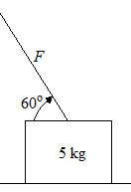

(A) 10 m/s2

(B) 12 m/s2

(C) 24 m/s2

(D) 30 m/s2

(E) 36 m/s2

8. A 1.2 µF capacitor in a flash camera is charged by a 1.5 V battery. When the camera flashes, this capacitor is discharged through a resistor. The time constant of the circuit is 10 ms. What is the value of the resistance?

(A) 8×10–2 Ω

(B) 0.12 Ω

(C) 12 kΩ

(D) 12.8 kΩ

(E) 8.3 kΩ

9. A capacitor, initially uncharged, is connected in series to a 10 kΩ resistor and a 9 V battery. What is the initial current in this circuit?

(A) 6×10–2 A

(B) 7×10–4 A

(C) 5.4×10–5 A

(D) 0.9 A

(E) 9×10–4 A

10. The block has a mass of 500 g and h is 4 cm. The block starts from rest, and slides down the curve. If the coefficient of kinetic friction between the block and the flat portion of the ramp is 0.2, how far does the block travel along the flat portion of the ramp?

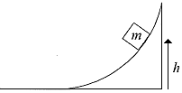

(A) 10 cm

(B) 20 cm

(C) 30 cm

(D) 40 cm

(E) 50 cm

11. A stunt driver starting from rest needs to achieve a speed of 27.7 m/s. If her vehicle accelerates at 7.61 m/s2, what distance must she travel to achieve the desired speed?

(A) 16 m

(B) 59 m

(C) 22.5 m

(D) 40.8 m

(E) 50.4 m

12. A body loses 3430 J of potential energy in falling through 50 m. If the gravitational acceleration is 9.8 m/s2, then the body has a mass of

(A) 5 kg

(B) 3 kg

(C) 7 kg

(D) 8 kg

(E) 9 kg

13. A small object moving at 10 m/s to the right collides with a heavier object that is initially stationary. Which of the following is a possible velocity of the smaller object after the collision?

(A) 10 m/s to the right

(B) 5 m/s to the right

(C) 5 m/s to the left

(D) 12 m/s to the left

(E) 24 m/s to the left

14. The crane below uses a steel cable to lift one end of a 1000 kg iron sheet as shown. A 100 kg box sits on the sheet 2 m from its left end. If the sheet is 10 m long and of uniform density, what is the minimum tension in the cable?

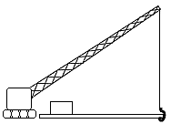

(A) 5200 N

(B) 5500 N

(C) 5800 N

(D) 11000 N

(E) 15000 N

15. 238U undergoes seven alpha decays and six beta decays to make:

(A) 210Po

(B) 210Pb

(C) 210Bi

(D) 206Pb

(E) 234Pb

16. A block of wood measuring (5×3×10)cm has a mass of 90 grams. What is the density of the wood?

(A) 1.6×l02 kg/m3

(B) 6×102 kg/m3

(C) 1.6×l03 kg/m3

(D) 6×l03 kg/m3

(E) 6×l05 kg/m3

17. A 75 kg man stands on a 10 m long block which floats on the water as shown. The block is half metal and half massless styrofoam. If the mass of the block is 100 kg, how far from the right end of the block should the man stand in order to keep the block level?

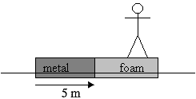

(A) 1 m

(B) 1.7 m

(C) 2.5 m

(D) 3.3 m

(E) 4 m

18. A 2 kg block slides down a 3 meter long, frictionless 30° incline. How much work does gravity do on the block?

(A) 30 J

(B) 40 J

(C) 50 J

(D) 60 J

(E) 90 J

19. A hollow 0.2 kg ball is released from the bottom of a pool and is propelled upward by a 9 N buoyant force. The depth of the pool is 2 m. If frictional forces were neglected, with what speed would the ball reach the surface? (Use g = 10 m/s2.)

(A) 20 m/s

(B) 7.5 m/s

(C) 75 m/s

(D) 11.8 m/s

(E) 15.5 m/s

20. One of the strings on a certain guitar is 36 cm long. What is the length of the third harmonic for this string?

(A) 18 cm

(B) 24 cm

(C) 36 cm

(D) 72 cm

(E) 80 cm

21. A book whose mass is 2 kg rests on a table. Find the magnitude of the force that the table exerts on the book. (Use g = 9.8 m/s2.)

(A) 15 N

(B) 19.6 N

(C) 25 N

(D) 40 N

(E) 0 N

22. What is the voltage across the 2 ohm resistors and the current through either 2 ohm resistors?

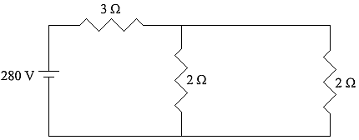

(A) 70 V, 35 A

(B) 112 V, 66 A

(C) 80 V, 40 A

(D) 80 V, 20 A

(E) 80 V, 80 A

23. For the circuit shown below, what is the voltage of the battery (assuming the battery has no internal resistance)?

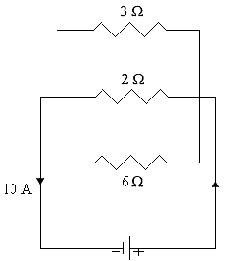

(A) 1 V

(B) 5 V

(C) 10 V

(D) 50 V

(E) 100 V

24. A 0.12 µF capacitor, initially uncharged, is connected in series with a 10 kΩ resistor and a 12 V battery of negligible internal resistance. Approximately how long does it take the capacitor to reach 90% of its final charge?

(A) 5.5 ms

(B) 2.8 ms

(C) 1.4 ms

(D) 3.5 ms

(E) 6.9 ms

25. An electron (*q* = –1.6×10–19 C) is traveling east with an instantaneous velocity of 2.5×105 m/s when it enters a uniform magnetic field of 0.45 T that points 35° north of east. What are the magnitude and direction of the force on the electron?

(A) 1.8×10–14 N up

(B) 10–14 N down

(C) 1.5×10–14 N up

(D) 1.6×10–14 N down

(E) 10–14 N up

26. The charge stored in the 6 µF capacitor *C*1 is nearest to

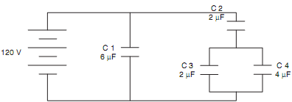

(A) 300 µC

(B) 550 µC

(C) 600 µC

(D) 750 µC

(E) 900 µC

27. A cell of emf $ε_{0}$ is connected, in series, to a capacitor *C* and a resistor *R*. The correct relationship regarding the circuit is

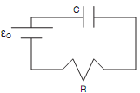

(A)

(B)

(C)

(D)

(E)

28. The number of excess electrons on a nonconducting sphere that has a charge of –9 nC is closest to

(A) 2×108

(B) 4×108

(C) 2×1010

(D) 4×1010

(E) 6×1010

29. The number of Joules of energy delivered to a motor if 7.5 Coulombs passes through it from a 24 V battery is most nearly

(A) 100 J

(B) 200 J

(C) 300 J

(D) 400 J

(E) 500 J

30. The total charge acquired by the capacitors is most nearly. (Two capacitors, 0.4 µF and 0.5 µF are connected in parallel and charged to a 90 V potential difference).

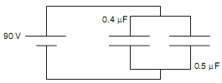

(A) 0.08 µC

(B) 0.8 µC

(C) 8 µC

(D) 80 µC

(E) 800 µC